July 8, 2022
To: Kramer Consulting and Ross Strategic
Re: Draft LSRD Benefit Replacement Study
Delivered via email to info@lsrdoptions.org

Dear Mr. Kramer,
The “Lower Snake River Dams: Benefit Replacement Draft Report,” Chapter 7, titled “Energy Replacement,” confirms that we can replace and improve the energy services of the lower Snake River dams (LSRD) with smart planning and adequate funding.
The draft report highlights that there is sufficient information available now to make a regional decision in favor of retiring the LSRD from service, and that doing so is less expensive than the status quo. Each analysis cited by the draft report concluded that the energy services of the dams can be replaced with a portfolio of clean energy resources. The appropriate planning objective, precise mix of resources, and exact cost of development are important dimensions that future detailed study will define, but the draft report’s conclusion that replacement is feasible with smart planning confirms that we can and should decide to move forward with replacing these dams and their services.
We agree with the draft report’s conclusions that: (1) the LSRD energy services can be replaced with an affordable, diverse portfolio of clean energy resources that should be in place prior to shutdown of the dams; and (2) constructing the replacement resource portfolio can address the seasonal limitations of LSRD performance and improve value for the overall Northwest power system, especially in late summer when lower Snake River flows will decrease under the influence of climate change.
The major shortcoming of the draft report is that it fails to provide a 50-year cost and risk comparison between keeping the LSRD and replacing them with a clean energy portfolio. Without this information, decision-makers and the public are left with an incomplete picture of clean energy net benefits, including increased protection for salmon and other fish and wildlife, and improvements to the value and performance of the Northwest power system. Even apart from the billions of dollars the region has spent on insufficient measures and the billions more the region will spend over the next 50 years if we keep the dams, we know that the benefits of breaching the dams substantially exceed the benefits of keeping them. The science is clear that keeping the dams will lead to salmon extinction and breaching them will not. Dam breaching is the key to restoring wild salmon and steelhead to abundance, alongside other necessary measures.
The high-end cost estimates the draft report provides for replacement power are founded on analysis from the Columbia River System Operations Environmental Impact Statement’s (CRSO EIS) completed during the previous administration that’s been sharply criticized and is currently the subject of active litigation. In 2020, NW Energy Coalition, Idaho Conservation League, and other conservation groups submitted comments on the draft CRSO EIS which were not satisfactorily addressed in the final EIS. Failures of this analysis, among other problems, became the basis for current litigation over the CRSO EIS. We have attached our comments on the draft 2020 CRSO EIS.
Below is a detailed analysis of each section of Chapter 7 of the draft report, “Energy Replacement.”
Existing Services of the LSRD
The draft report provides a general summary of the existing energy services of the LSRD and shows how climate change and legal challenges will constrain their value in the future. The evidence summarized in the draft report shows that while the dams provide valuable services, these services are more limited than is commonly understood. If four additional facts, detailed below, are considered, the value is even further reduced.
First, while the draft report does include both the cost of generation and fully-loaded costs of the LSRD in Table 13, the cost of generation and fully-loaded costs are not the most current figures. LSRD costs increased in the most recent Bonneville Power Administration (BPA) rate case (BP-22), indicating that the cost of generation at the LSRD is higher than at Headwaters projects, and significantly higher than at Mainstem Columbia projects.
Furthermore, as mentioned above, Table 13 doesn't project the long-term cost of continued LSRD operation over the next 50 years. Long-term costs would include ongoing and future capital costs of LSRD energy generation, especially equipment replacement for facilities that have been in operation for 45 to 70 years, as well as the costs of maintaining other services, like navigation. Long-term costs would also include modifications to the dams and their operations in a changing climate to meet Washington water quality standards and reduce hot water pollution for salmon as required by law and recently affirmed by the Washington Pollution Control Hearings Board (PCHB).
Second, the draft report recognizes that Ice Harbor dam provides grid reliability support for the Tri-Cities area, but fails to consider that Columbia Generating Station is the dominant generation resource in the area. Longstanding transmission and distribution system upgrades have been previously identified and will be needed regardless of whether the LSRD continue in operation or are replaced. Treating these upgrades as a cost only associated with dam removal is inaccurate. New utility-scale renewable and storage resources in the area plus a range of customer side resources (demand response, distributed generation, storage and energy efficiency) can also enhance, defer, or eliminate the need for new high-cost transmission facilities to support the Tri-Cities.
Third, the initial description of LSRD energy as “carbon-free” in the draft report is contradicted by later descriptions of research showing methane emissions from dam-impounded reservoirs like those on the lower Snake. Hydropower is deemed “non-emitting” under Washington state law, but the final report should be clear in its definition of “carbon-free” and note that research into climate impacts of dam-impounded reservoirs is just beginning to emerge.
Fourth, the data shown by Figure 10 in the draft report does not represent a projection of power generation during 2022. Rather, it reflects BPA’s power generation and load under 1937 critical water year conditions. We recommend using data on the actual production of the system, which would better represent how the LSRD function and their incremental value for the system. Even BPA has recently moved away from using 1937 water year data, as they no longer accurately represent the climate change-impacted hydrograph. The final report should use historic generation averages from all resources on the BPA system and BPA load.

Changing Energy Environment
The draft report sets the LSRD energy services replacement issue in the correct context of the changing energy environment. The draft report correctly notes that the anticipated 2028 BPA contract renewals can benefit from more clarity around the future of the LSRD, and a properly structured clean energy replacement portfolio can fill the seasonal gaps the LSRD currently cannot address.
Furthermore, the draft report acknowledges that future court decisions could further limit dam operations. The report points to the 2020 CRSO EIS scenario Multiple Objective Alternative 4 (MO4) to illustrate this risk. MO4 has the highest cost of any of the alternatives because it relies on maximizing spill across the Lower Snake and Lower Columbia dams, rather than breaching the LSRD. MO4 does not achieve the anticipated benefit to salmon survival and recovery from dam breaching and replacement, which is scenario MO3. It is uncertain whether dam breaching could be ordered by a court, but past legal challenges to dam operations have resulted in steadily increasing requirements for spill that reduced power generation. The current legal challenges to the 2020 CRSO EIS could lead to MO4-like operations within the Federal Columbia River Power System.
In addition to the CRSO litigation, the draft report should consider that Washington State recently asserted its right under the Clean Water Act to enforce state water quality standards for salmon at the dams, including for hot water pollution. The state’s rights were challenged by the U.S. Army Corps but, ultimately, upheld by the Washington PCHB. Meeting state water quality standards for temperature at the four LSRD reservoirs creates even further uncertainty about constraints to operations (e.g. possible drawdown) and future cost.
Actions Needed to Replace or Improve Services
First, the draft report states, “Replacement of the LSRD energy production with renewable, carbon-free sources is a small percentage of the regional need forecast for 2050 but adds to the challenge.” However, the draft report does not place the LSRD replacement energy production in context of the region’s high interest in renewable energy development. The draft report does not recognize Energy Strategies 2022’s finding that an LSRD replacement clean energy portfolio represents just 12% of resources that are currently in BPA’s queue – which will not be the only source for replacement resources – for development in the late 2020s (Figure 1). The final report should note that interest in development of clean energy generation in the Northwest is high and growing, and that LSRD energy replacement would represent only a small fraction of the total planned, “shovel-ready” clean energy resources being driven by market conditions.
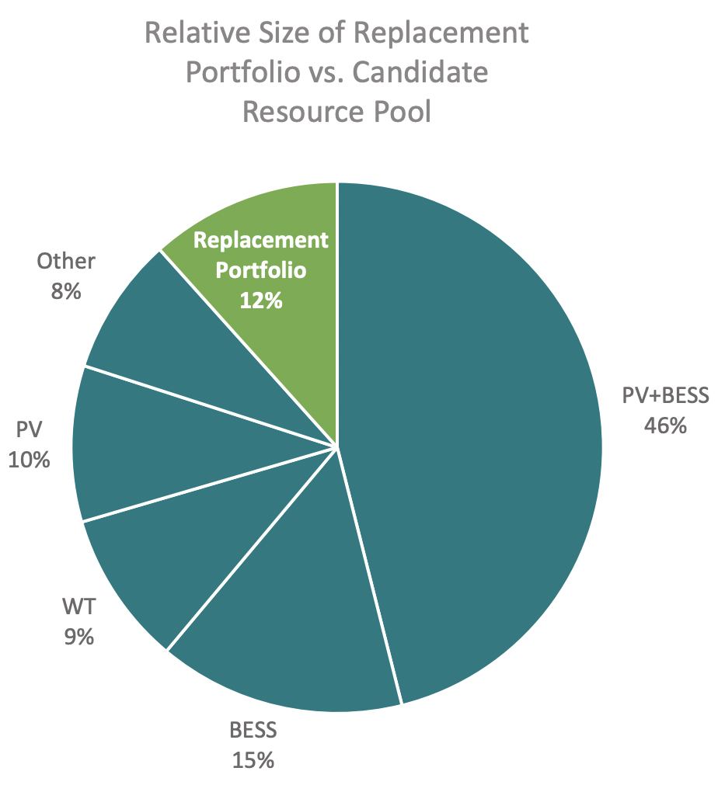
Figure 1: Relative size of Energy Strategies’ replacement portfolio vs. all resources (solar (PV), wind (WT), BESS (storage), PV+BESS (hybrid solar and storage)) currently in BPA’s queue. Source: Energy Strategies 2022.
Additionally, the draft report does not directly address the rapid advances of regional utilities in replacing much larger coal power plants (Figure 2) with clean generation, storage, and customer side replacement resources scheduled to be in operation within the next five years. This new development pipeline creates significant opportunity for LSRD clean energy replacement. The final report should include past and current resource replacements as examples for how LSRD replacement could proceed.
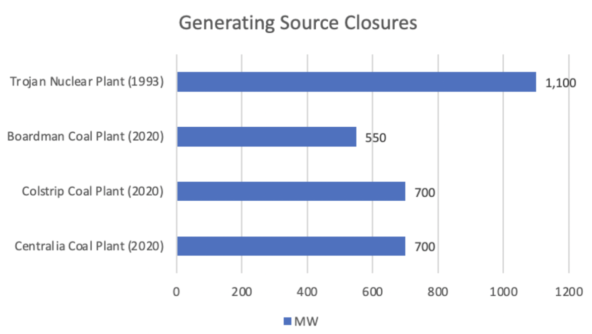
Figure 2: Power output of retired generating resources.
Second, the draft report estimates energy replacement costs using a simplified method in which costs are projected over 50 years. However, the draft report does not contain a similar projection for the costs of keeping the dams over an equivalent timeframe. Beyond maintenance and upkeep for this aging infrastructure, we know that the benefits of replacing the dams substantially exceed the benefits of keeping them. The science is clear that keeping the dams will lead to salmon extinction and breaching them will not. The final report should be clear in its assessment of the costs and risks of inaction.
Third, the cost projection makes the overall costs of the energy replacement portfolio appear inflated when compared to other resource cost methodologies commonly used in resource planning, such as annualized capital costs. The final report should use these other cost methodologies when comparing the costs of energy replacement vs. keeping the dams in place. In addition, it’s expected that once replacement moves forward, the region would undergo a competitive procurement process to choose the right clean energy resources to replace the dams. This process would create the optimal clean energy generation portfolio, at the best cost available on the open market. The final report should make this clear in reporting cost estimates of energy replacement.
Fourth, cost increases in the studies summarized in the draft report are generated from a one-to-one replacement of LSRD services, but, based on Energy Strategies 2022, the report also shows that we can choose a portfolio that better matches future supply and demand and significantly decreases the net costs of replacement. The study does report on Energy Strategies 2022 and its optimized replacement mix but it doesn’t directly address this point or the additional revenue these improved replacement portfolios will generate by producing more power when it’s more valuable. The final report should make this clear and report on the annual net costs of both the current system and a replacement energy portfolio.
Fifth, it is heartening that the draft report highlighted the necessity of equity in any future path for the LSRD, especially for low-income customers and vulnerable communities. However, the report misstates the legal standard under the Clean Energy transformation Act (CETA) by saying, “If the cost of the replacement portfolio falls on regional ratepayers, this would likely lead to rate increases across BPA customers and could run counter to the provisions within CETA that require the energy burden is reduced for low-income customers.” CETA does require that Washington utilities offer assistance to reduce energy burden. However, the relevant standard in CETA is the requirement to ensure “the equitable distribution of energy benefits and reductions of burdens to vulnerable populations and highly impacted communities; long-term and short-term public health, economic, and environmental benefits and the reduction of costs and risks; and energy security and resiliency.” The LSRD have had an inequitable burden on vulnerable communities, specifically Tribes that rely on salmon for health and economy, for decades. We can replace the LSRD, meet our state energy goals, and reduce energy, health, environmental, and economic burdens on vulnerable communities simultaneously.
Sixth, the draft report states that continued advancement of battery technology is necessary to address future dispatchable energy needs. The final report should be clear that while it may be true that future technology development will make replacing the services of the LSRD even easier, current battery technology, effectively deployed, can replace the energy services of the LSRD. Multiple analyses, ³ even the 2020 CRSO EIS, ² have shown that currently available clean energy technologies, including existing 4-hour storage battery technology, can replace and improve upon the energy production of the dams. The draft report cites recent rapid expansion of battery storage in California, which is expected to continue. Development data from this year shows the trend is nationwide. Despite supply challenges, first quarter energy storage development quadrupled in 2022 compared to the same period in 2021. In addition, longer-duration storage is no longer a technology of the future – it is being deployed now. Recently, a Department of Defense facility contracted with Lockheed Martin to deploy a new "flow battery", which will provide 10-hour energy storage as a pilot project, expected to break ground this fall. Flow batteries of this type are already being deployed across the globe as a complement to the standard lithium batteries. Further development and penetration of these technologies will make LSRD replacement easier and cheaper. These technologies are available now and will continue to scale up as the region seeks to replace the energy services of the dams.
Seventh, the draft report cites the Zero-Carbon portfolio assembled by the 2020 CRSO EIS, but misstates how development of the portfolio would affect regional reliability:
On page 67, the report states: “The 2020 CRSO EIS Zero-Carbon portfolio includes solar generation in eastern Oregon as well as demand response in Seattle, Spokane and Portland to replace the energy production and services provided by the LSRD. The 2020 CRSO EIS forecasts that this replacement portfolio would lead to a 13.8% loss of load probability (LOLP).”
On page 68, the report states: “However, according to the 2020 CRSO EIS, if the annual energy provided by the LSRD were to be replaced by these energy sources the probability of a LOLP is expected to double compared to current operations from 6.6% to 13.8%.”
These LOLP statistics are being used incorrectly. The EIS concludes that implementing MO3 would result in a Loss of Load Percentage (LOLP) of 14% before any replacement resources are constructed (Table 2-10). The analysis then identified a portfolio of resources that could be built to reduce LOLP to that of the No Action Alternative (6.6%). So, development of either the least-cost portfolio or the Zero-Carbon portfolio would result in an LOLP of 6.6%, not 13.8%, as the draft report states. This analytical process is laid out on page H-2-10 of the CRSO EIS.²
Eighth, the draft report’s description of Energy Strategies 2022 is inaccurate. It states: “The higher end of this [cost] estimate represents a one-to-one replacement portfolio of the average generation output of the LSRD, which has additional solar to compensate for ramping capacity to account for the early morning peak in the winter.” This isn’t true of the Base (LSR Dam Shape) portfolio assembled by Energy Strategies. The Base portfolio does contain more solar resources, but this is to provide generation equivalent to the LSRD in spring, when they generate most of their energy (and the value of that energy is very low), not to compensate for ramping capacity.
Ninth, the draft report misstates the amount of generation the region would need to replace if the LSRD are breached. Early in the section on Energy Services, the report states the dams produce 940 aMW per year. Later the report states “If the LSRD were to be breached, the Pacific Northwest Energy System would need to replace 1,137 aMW of energy during a regular water year compared to current operations.” The final report should address this inconsistency.
Tenth, the draft report mischaracterizes the inclusion of demand response and power purchases costs in Energy Strategies 2022. These costs were included in the original report, though not in the appended capital costs analysis. Reporting on the annual net cost of energy replacement would include these costs.

We appreciate the work done by the consultant team in preparing the “Lower Snake River Dams: Benefit Replacement Draft Report” and we thank Senator Murray and Governor Inslee for their ongoing commitment to salmon and steelhead recovery. We agree with the conclusions laid out in the draft report: LSRD energy services can be replaced with an affordable, diverse portfolio of clean energy resources that can be optimized to improve value for the overall Northwest power system and salmon recovery; and the portfolio should be in place prior to shutdown of the dams. We look forward to engaging for the remainder of this report’s process.

Nancy Hirsh
Executive Director
NW Energy Coalition

Mitch Cutter
Salmon & Steelhead Associate
Idaho Conservation League

Todd True
Senior Attorney
Earthjustice

Joseph Bogaard
Executive Director
Save Our Wild Salmon

Bill Arthur
Director
Sierra Club Salmon Campaign

Giulia Good Stefani
Senior Attorney
Natural Resources Defense Council

Angus Duncan
Consultant
Natural Resources Defense Council

Stephen Pfeiffer
Conservation Associate
Idaho Rivers United

Page 31 of Bonneville Power Administration’s Integrated Program Review, June 2020
Record of Decision, Columbia River System Operations Environmental Impact Statement, October 2020
Lower Snake River Dam Replacement Study, Energy Strategies, May 2022
Energy storage soars despite international and national supply challenges: report, Utility Dive, June 2022
Lockheed Martin gets contract to build long-lasting battery storage system at Fort Carson, Denver Gazette, June 2022
Can flow batteries supercharge the energy transition?, Energy Monitor, June 2022

